Specification Documentation

GUEST PORTAL

Solace Technology Pty Ltd

|  |  |
| --- | --- |
| **Version:** | 1.1 |
| **Author:** | Christie Glasson |
| **Date:** | 28/05/2015 |

This document provides a high level overview of the guest experience from a retail perspective and describes their interaction with Solace through the Guest Portal

# Version Control

The following is a list all changes made to this document, the person making the change, the new version number and the reason why the change was necessary.

| Date | Author | Version | Change Description |
| --- | --- | --- | --- |
| 28/05/2015 | CG | 1.1 | First Draft |
|  |  |  |  |
|  |  |  |  |

# Distribution List

The following list contains the names and organisational details of the people to whom this document has been distributed.

| Name | Organisation |
| --- | --- |
| Andrew Lombe | Solace Technology |
| Lyndal Johnson | Solace Technology |
| Ian Barry | Solace Technology |
| Christie Glasson | Solace Technology |
| Ed Lombe | Mico Systems |
| Saurav Acharjee | Mico Systems |

# Table of Contents

1. Version Control 2

2. Distribution List 3

3. Table of Contents 4

4. Terms and Naming Conventions 5

5. Purpose & Business Process Description 6

5.1 Background & Purpose 6

5.2 Business Data Model 6

6. Scope 7

6.1 Scope defined using the Business Data Model 7

7. Description 8

7.1 Guest Portal Overview 8

7.2 User Characteristics 8

7.3 Suggested Technology 8

7.4 User Platforms 9

7.5 Visual Benchmarks 9

7. Features 12

8. High Level Experience Flows 18

# Terms and Naming Conventions

The following table contains a list of the terms specific to the project:

| Term | Definition |
| --- | --- |
| *Solace* | Describes the entire system instance to each individual Solace Technology Pty Ltd client. |
| *The Business* | Solace Technology Pty Ltd client using an instance of Solace. |
| *The Supplier* | Any business that has a commercial relationship with The Business in terms of making available property or products for sale through The Business in exchange for a commission. |
| *The Agent* | Any business that has a commercial relationship with The Business in terms of selling property or products supplied by The Supplier in exchange for a commission. |
| *The Guest* | An end user purchasing a holiday experience based on the offerings of The Supplier, though the Business. This transaction can be facilitated through The Business, the Guest Portal, The Agent or other sites powered by Channel Managers that are interacting with Solace. |
| *Business Console* | A web based Solace interface used by The Business to facilitate bookings, administration and management of Solace. Branded Solace and used by The Business’ staff and consultants. |
| *Agent Portal* | A web based Solace interface used by The Agent to facilitate bookings completed on behalf of The Business. Business Branded and used by The Agent’s staff and consultants. |
| *Supplier Portal* | A web based Solace interface used by The Supplier to facilitate the management of product and/or property offerings available for sale through Solace. Business branded and used by The Supplier’s staff. |
| *Guest Portal* | A web based Solace interface used by The Guest to facilitate the purchase of property and/or product. Enables The Guest to search, purchase, pay for, amend and cancel offerings using an intuitive, clean, secure, mobile responsible site. Business branded. |

# Purpose & Business Process Description

## Background & Purpose

Solace is a cloud based, reservation system that is unique in the way it delivers multiple property and product offerings from 3rd party suppliers, facilitates the bundling of these offerings to a retail client through a streamlined, seamless, single transaction. This could be delivered to The Guest via direct contact with The Business and utilisation of the Business Console, via The Agent utilising the Agent Portal, or managed themselves using the Guest Portal.

Solace manages the payments into The Business by The Guest and The Agent, calculates taxes and commissions, and manages the distribution of funds to The Supplier based on their specific terms of payment.

Solace allows integration with accommodation Channel Managers such as SiteMinder, RTP for Ski Resort product sales, and other 3rd party systems such as Alpine Sports Ski Rental system on a “pay to connect” basis. The purpose of integrating with these systems is to reduce data duplication, reduce manual data entry and improve The Guest’s booking experience.

## Business Data Model

The below diagram shows the interaction of the various users with each other and with Solace.

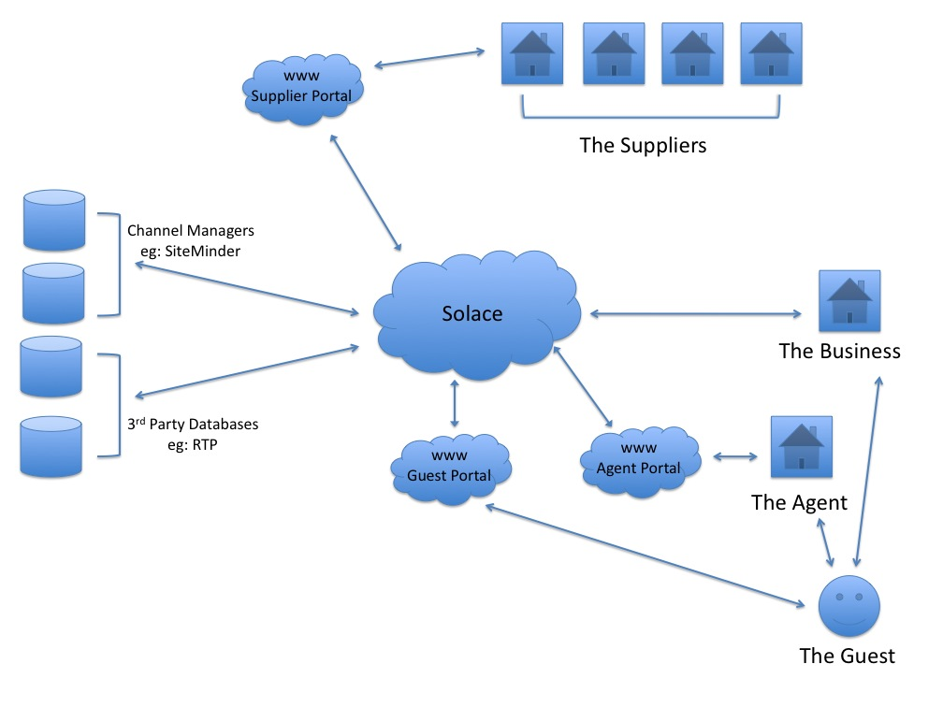

# Scope

This document is solely focused on the Guest Portal interface to Solace and does not provide an overall description Solace in its entirety.

## Scope defined using the Business Data Model

Below is the Business Data Model that highlights the module/s that are covered within the scope of this document.

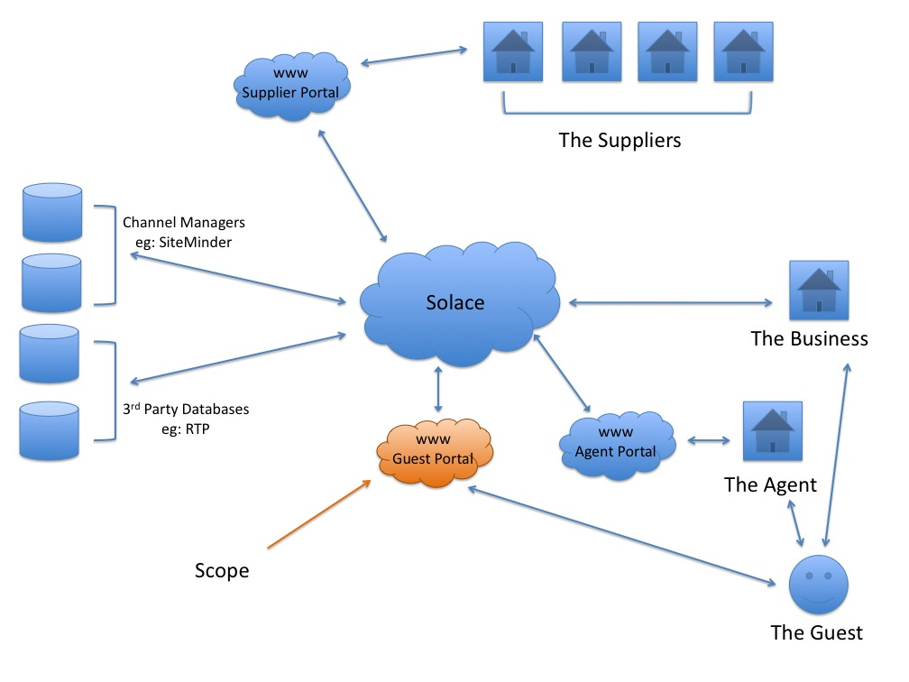

# Description

## Guest Portal Overview

The Guest Portal is integrated into The Business website and allows Guests the following experiences:

* Search property and product offerings
* View details of property and product offerings including availability, inclusions, maps, images, automated smart product offerings, etc
* Create potential holiday itineraries with the ability to save, email, create pdf, share and invite participants
* Ability to quickly and seamlessly convert their itinerary into a sale
* Accept and process payments
* Allow for “Bill Splitting” so other holiday participants can pay their share without burdening the holiday organiser
* Allow The Guest access to their holiday booking for reviewing and editing, or to make further payment, at any time, even after holiday completion, including automated responses to the business
* Allow The Guest the ability to interact with the Guest Portal on multiple devices through a responsive framework using a consistent approach.
* Automatically communicate with The Guest using their choice of either SMS or email at various milestones throughout the booking process as determined by The Business
* Invite The Guest to participate in property/product reviews after the completion of their holiday

## User Characteristics

The Guest Portal user is a diverse demographic and as such must be able to communicate to a wide audience. Almost everyone who is in the market for a holiday is a potential user.

The Guest Portal must be intuitive enough for the technologically challenged, but sophisticated enough to impress the technically savvy.

## Suggested Technology

Based on initial, high level research, a review of Bootstrap/HTML5/Less & CSS may be beneficial.

## User Platforms

All features of the Guest Portal must be available and fully functional from all devices. The look and feel between devices needs to be consistent and provide a seamless experience.

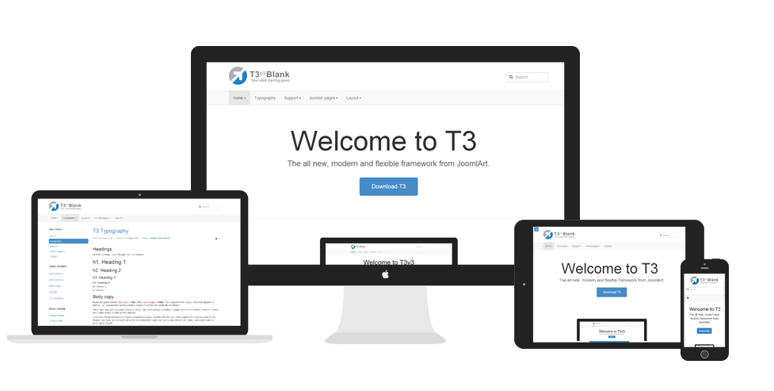

## Visual Benchmarks

The following sites demonstrate the style the Guest Portal features should emulate. Emphasis is on clean, simple displays that translate seamlessly to all devices.

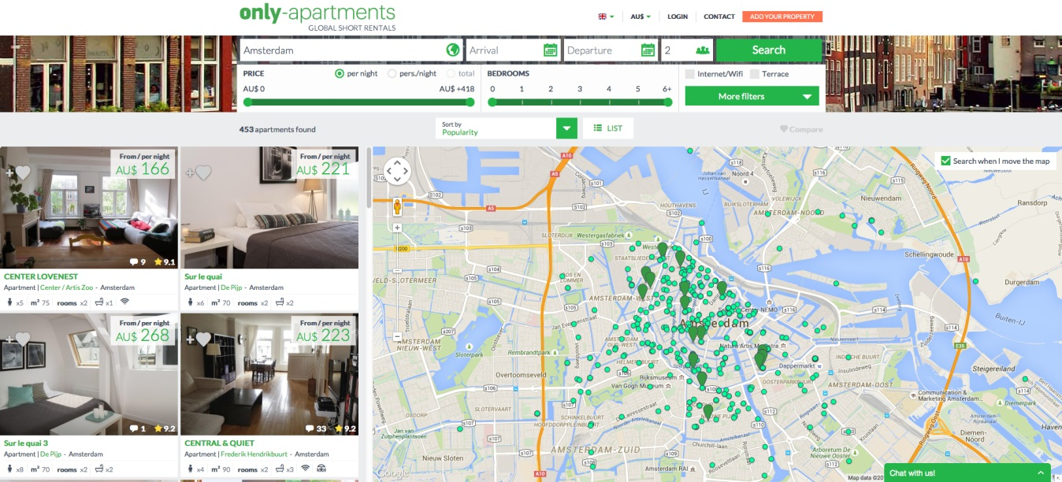[www.only-apartments.com](http://www.only-apartments.com)

[www.only-apartments.com](http://www.only-apartments.com)

|  |  |
| --- | --- |
|  |  |

[www.airbnb.com](http://www.airbnb.com)

|  |  |
| --- | --- |
| airbnb-1.jpg | airbnb-property-detail.jpg |

# Features

Below are some of the key features available to users of the Guest Portal. This list is not all inclusive.

**Opt-out / smart products. Automated upselling.**

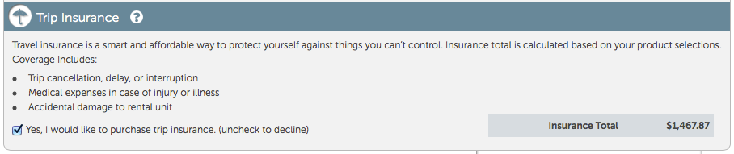  
**Intelligent product offerings based on customer preferences** *– (e.g. suggested itineraries to match holiday type)*

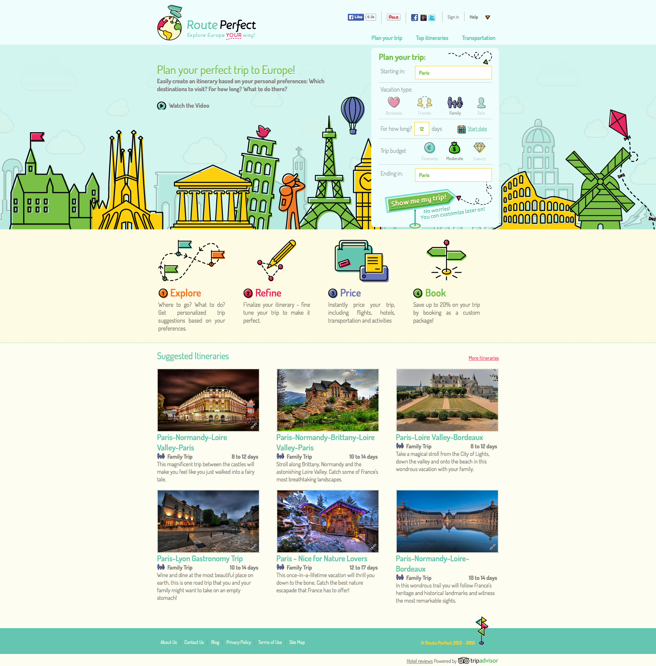

**Clean, simple search**

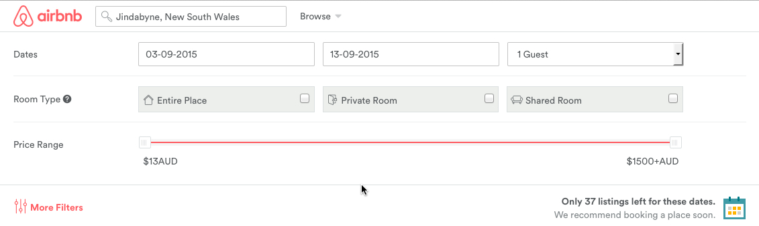

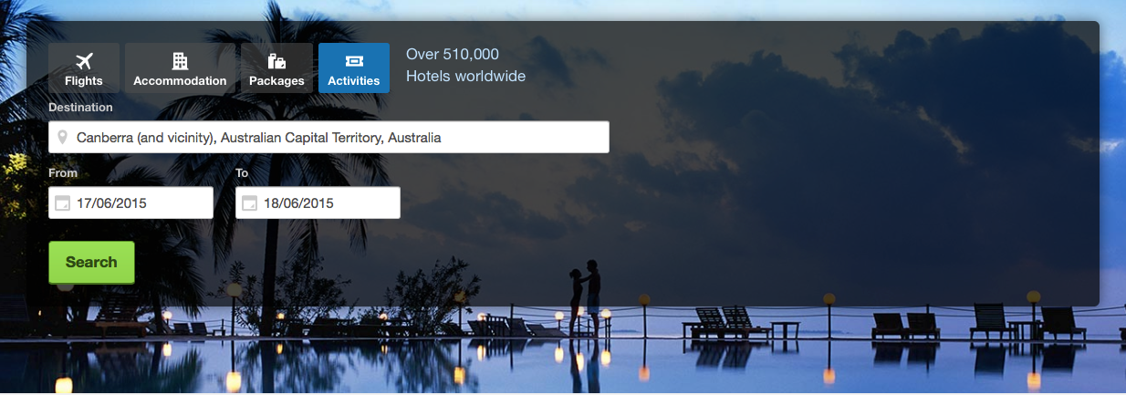

**Touch friendly, immediate response filtering options**

|  |  |
| --- | --- |
|  |  |

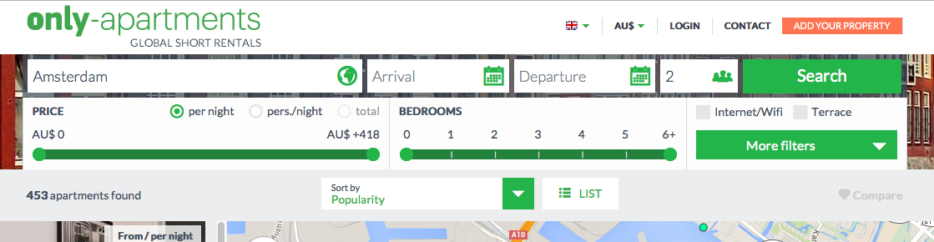

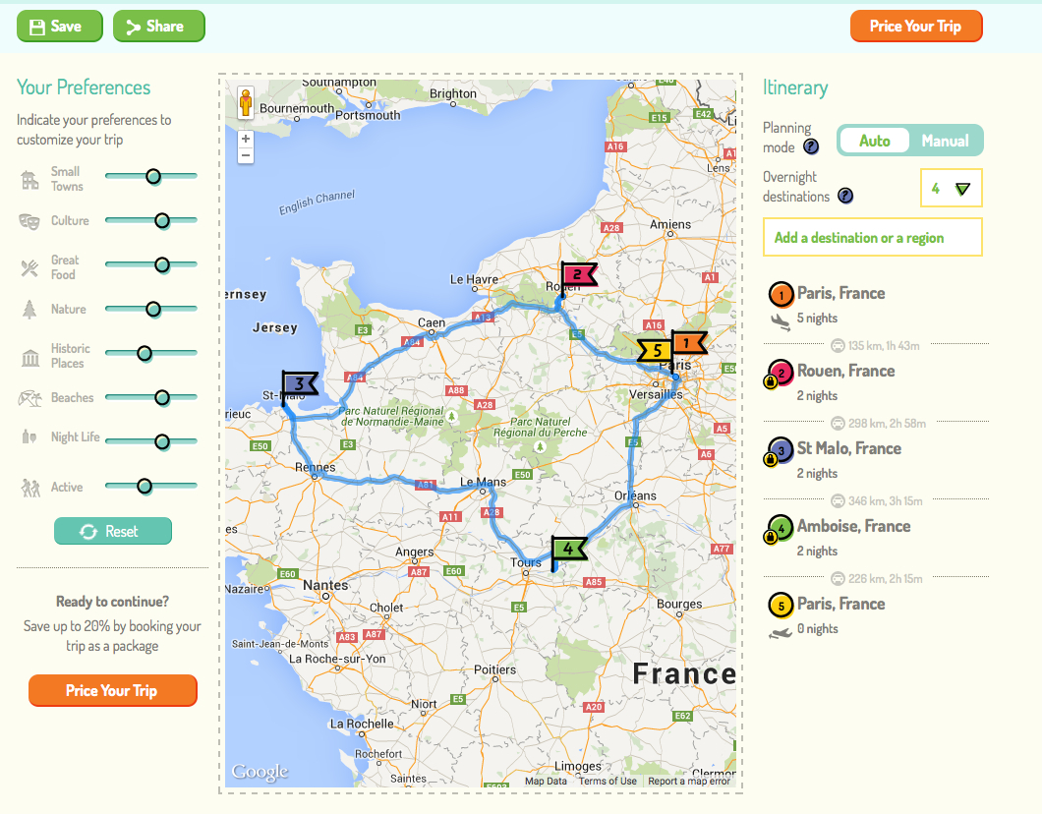

**Secure Guest Portal** – *(*[*www.travefy.com*](http://www.travefy.com) *- has some key features including – invite friends, share, itinerary builder)*

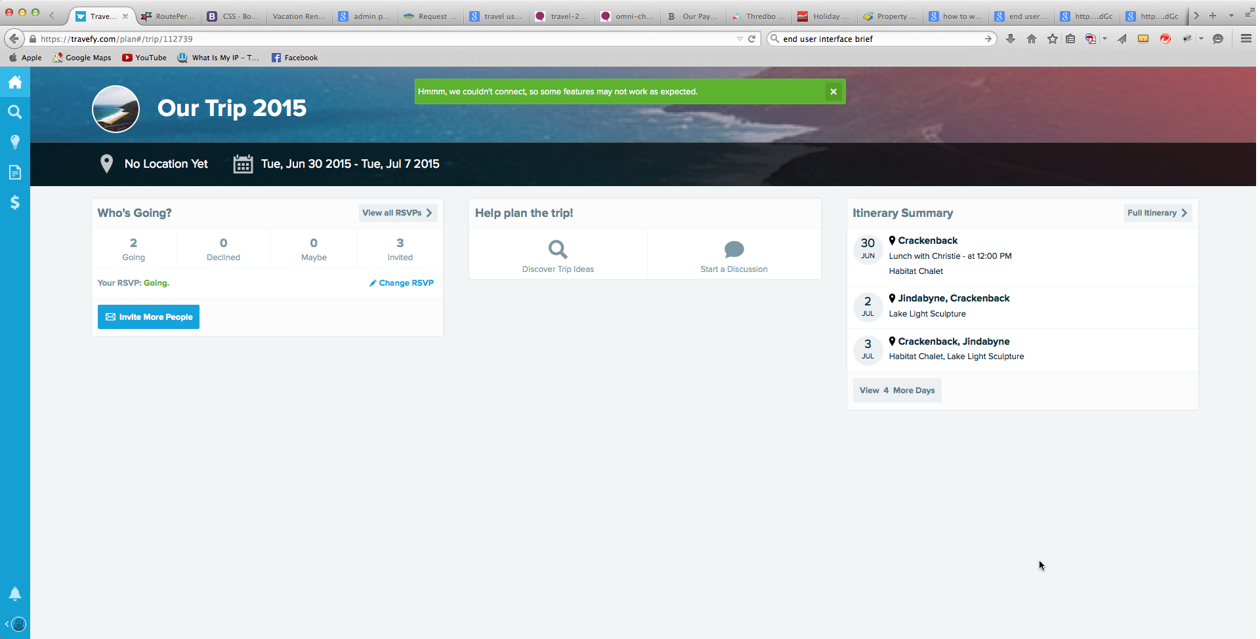

**Drag and drop feature.**

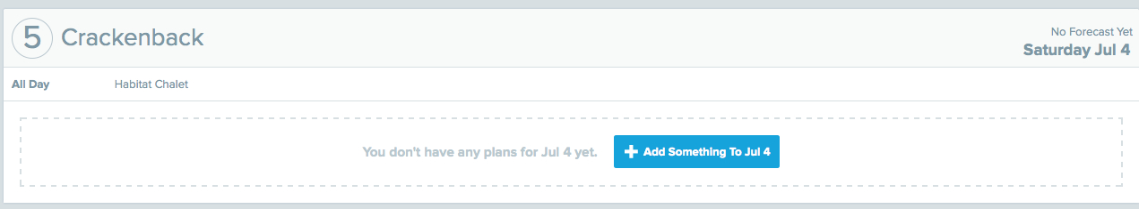

**Drag and drop functionality –** *(*[*www.travefy.com*](http://www.travefy.com)*)*

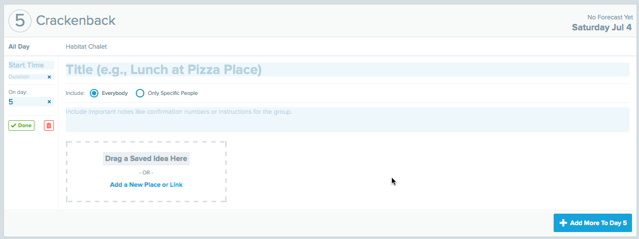

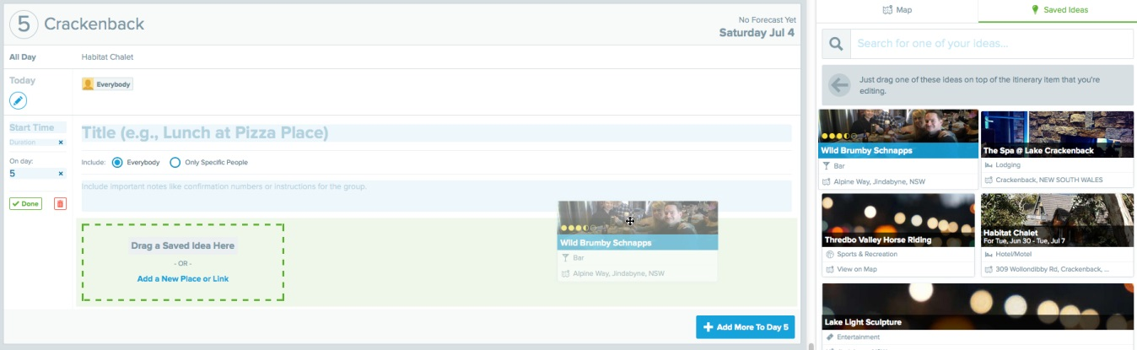

**Add to wishlist and realtime feedback**

|  |  |
| --- | --- |
| solace-real-time-feedback-1.jpg |  |

**Itinerary builder to display individual activities**

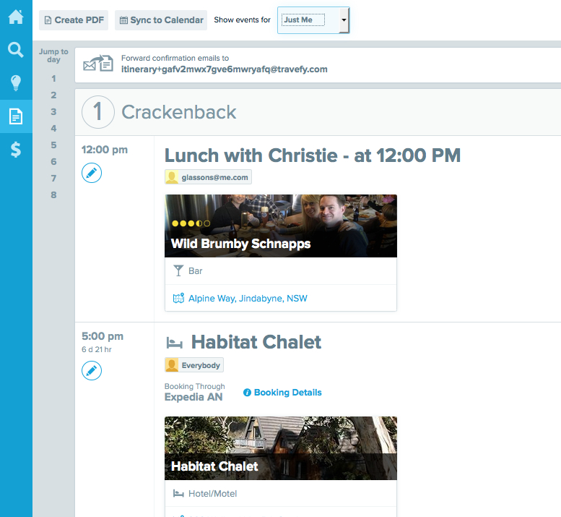

**User tools**



**Split Bill** *(*[*www.travefy.com*](http://www.travefy.com)*)*

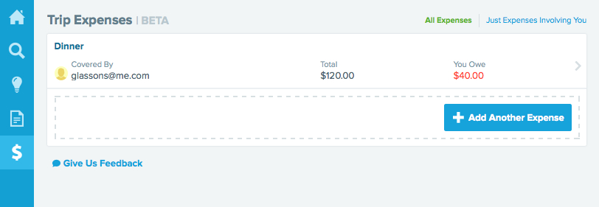

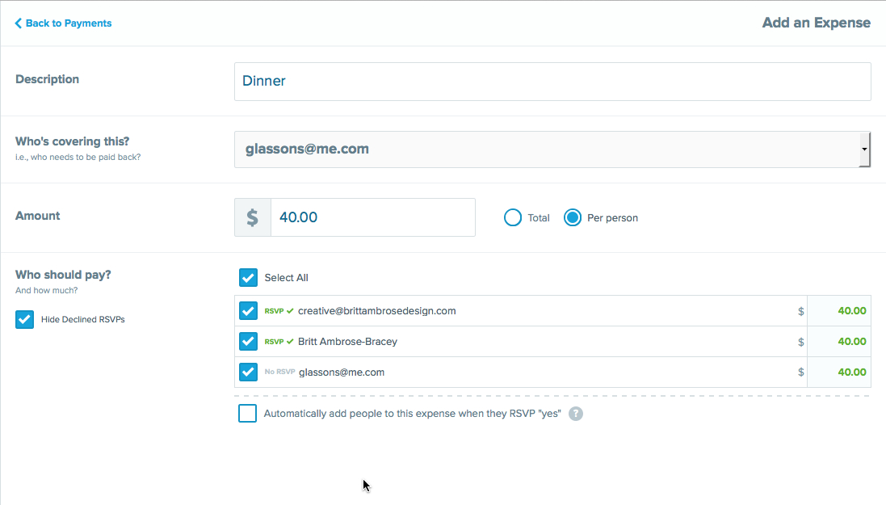

**Beautiful galleries**

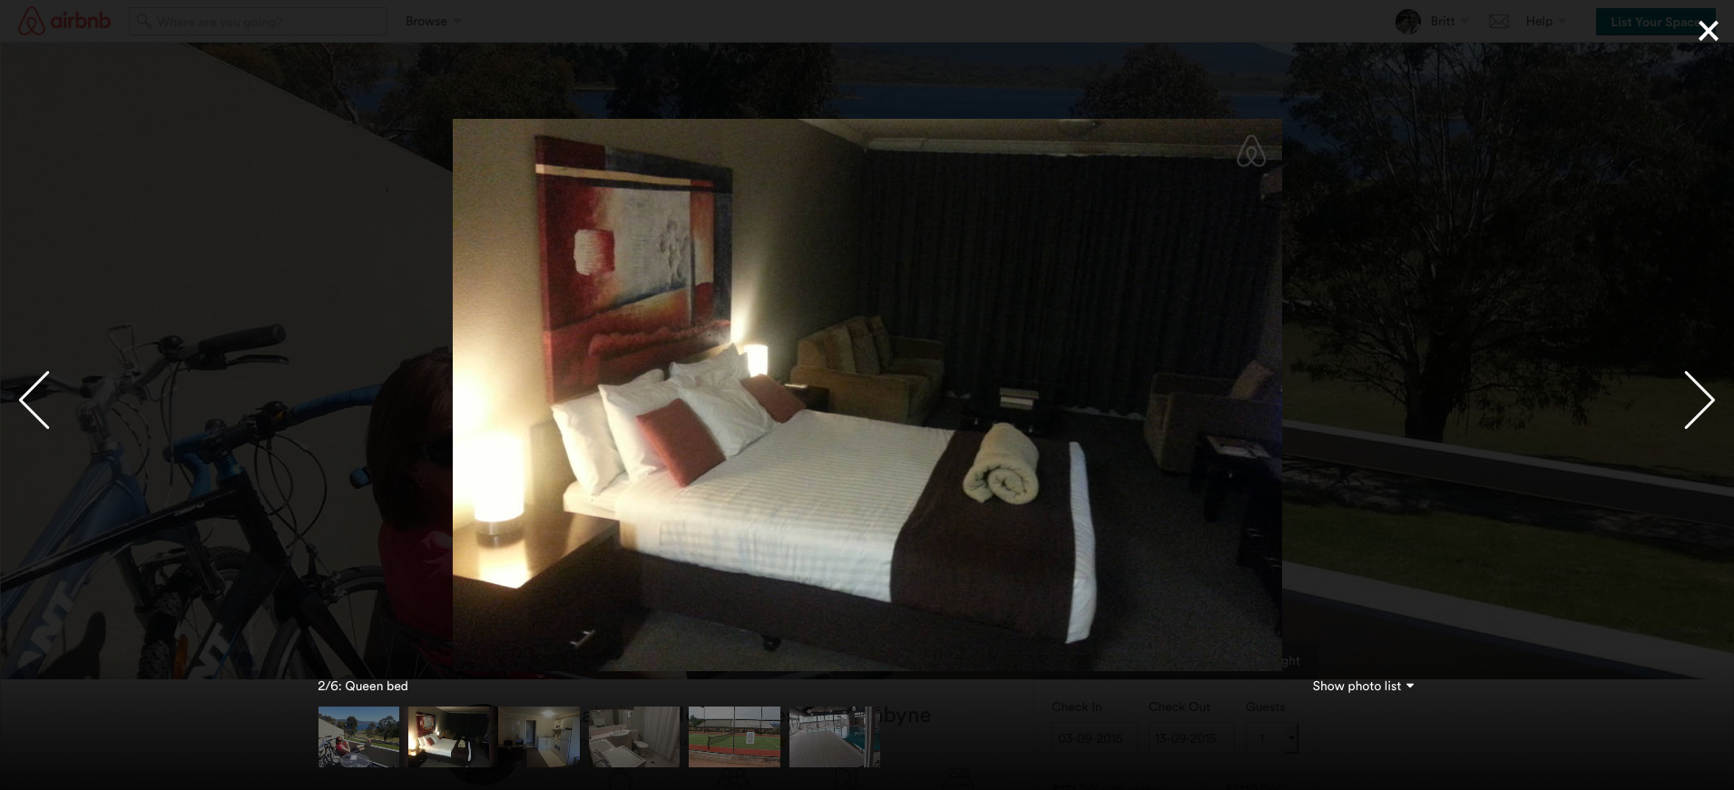

**Other features include:**

* Event calendar – add associated products to cart or drag & drop
* Interactive property availability calendar
* Secure online payment
* Google map view of product and property locations
* Pre-packaged itinerary that can be added to cart as is, or further customised
* Display markdown price next to original price
* Customer reviews/ratings
* Promo codes and gift vouchers
* Automatic SMS & email reminders
* View holiday history – retain guest itineraries including quotes

# High Level Experience Flows

Please refer to attached High Level Experience Flow document and sketches.